Case 17-AM,C-Taino-Anthropomorphic Head-First Type-Elongate Base-Fewkes

Anthropomorphic Heads.

These stone heads may have originated from the practice of maintaining ossuaries of important caciques or shamans since ancestor worship was a central aspect of Taino spirituality. In ceremonial practice these objects were the conduits to the spirit world and, as such, were consulted on issues of importance to the decision-making of prominent leaders. Features of these sculptures included head bands that may have indicated symbolic elements denoting a particular cacique or group, ear elements that often included a round ear spool below the ear itself, the shape of the chin in various degrees of sharpness, and the shape of the mouth, whether it be open as if in pronouncing an utterance or closed showing only dentition, suggesting a deceased ancestor’s skull.

Jesse Walter Fewkes suggested three types of these anthropomorphic heads. The first is with an elongated base. The second type according to Fewkes is ovate with a flat base. The third type is a head without an extended base.

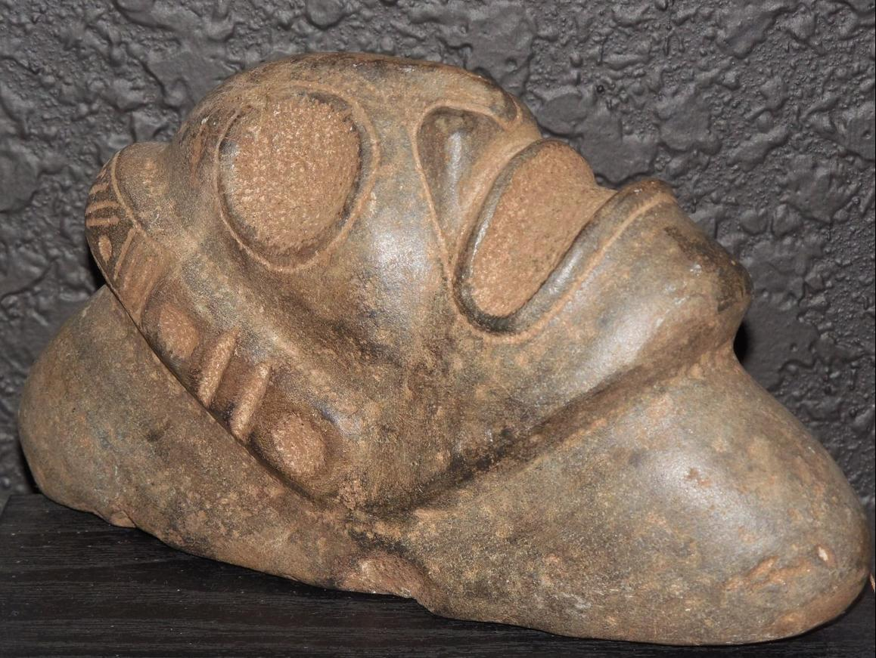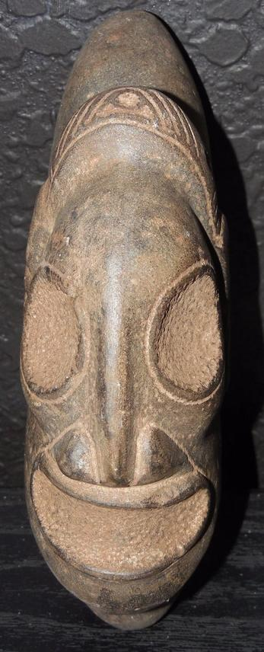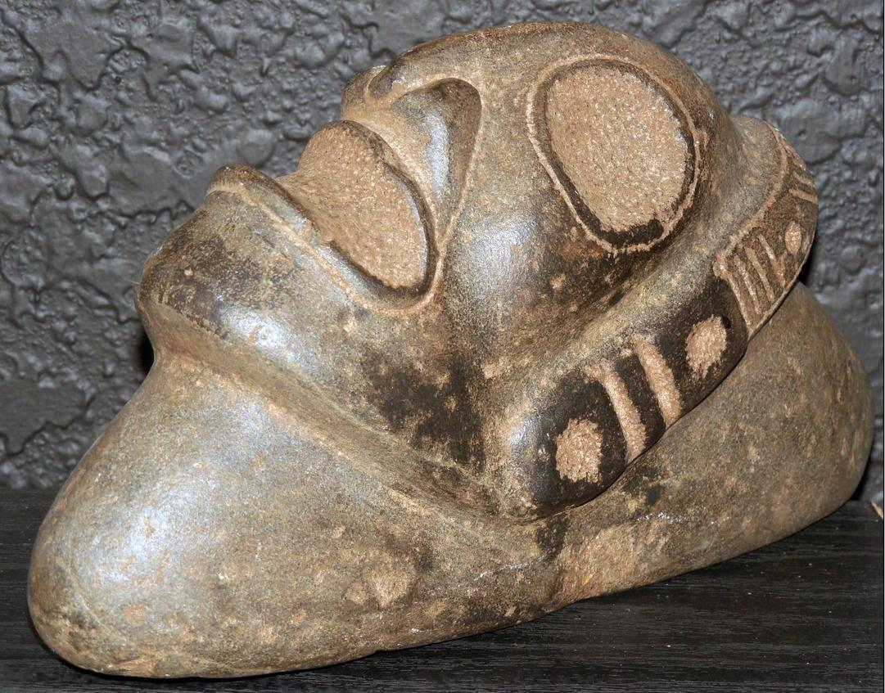

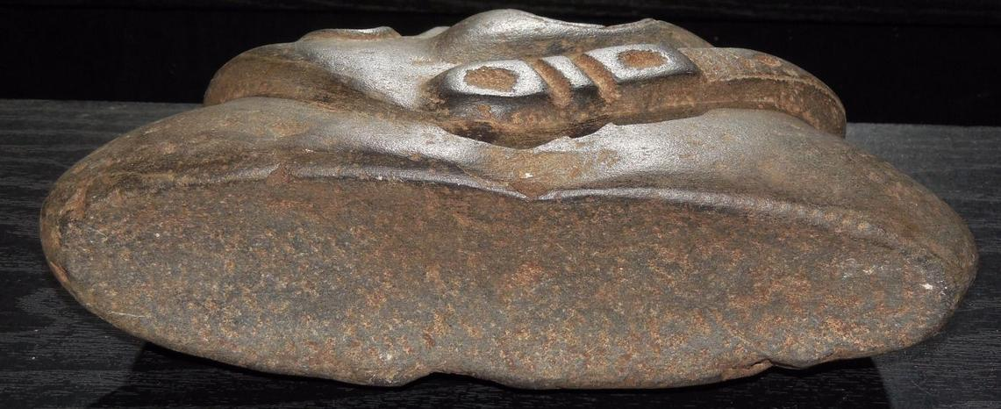

Anthropomorphic stone head, Fewkes type 2, ovate head with headband, ear spool and open mouth.